COMP101 LAB10

# Requirements

Extend the ThreeDice.java file to include scoring and then build a game based around the class which keeps track of multiple users scores for each round of game and produces a winner and several stats for the game

# Analysis and Design

My analysis of the problem is that I will need 3 additional classes above the given class, one class will use the threedice class to produce the scores achieved in the game, one will be responsible for the flow of the game and will execute the procedure for each round of the game and the final class will run the game and output the results.

## Pseudo Code

### Play round

INPUTS = NA

OUTPUTS = integer 2D array sized at players x 4

FOR number of players

ROLL THREE DICE

ADD TO ARRAY IN ORDER score, die1, die2, die3

END

RETURN ARRAY

### Play Game

INPUTS = NA

OUTPUTS = integer 3D array sized at Rounds x players x 4

FOR NUMBER OF ROUNDS

PLAY ROUND

ADD RESULT TO ARRAY

END

RETURN ARRAY

### GetRoundWinner

INPUTS = ROUND

OUTPUTS = INT(PLAYER)

TOPPLAYER = FIRST PLAYER

FOR EACH PLAYER

IF PLAYER> TOPPLAYER

TOPPLAYER = PLAYER

END

END

RETURN TOPPLAYER

## Class Diagram

|  |
| --- |
| gamePlay |
| INT players  INT rounds  INT[][][] scores  BOOL draw |
| playRound()– int[][]  playGame()– int[][][]  DieRoll()– int  GetRoundWinner()– int  GetWinner()– int  GetTotalScore()– int  GetAverage()– int  printStats() |

|  |
| --- |
| game |
|  |
| Main()  IntInput() – int |

|  |
| --- |
| ThreeDiceScorer |
|  |
| getStats() – int[] |

|  |
| --- |
| ThreeDice |
| INT die1  INT die2  INT die2 |
| getDie1() – int  getDie2() – int  getDie3() – int  threeSame() – bool  runOfThree() – bool  pair() – bool  allDifferent() – bool  printResult() |

# Testing

|  |  |  |
| --- | --- | --- |
| Players | Rounds | As Expected |
| 1 | 2 | Yes |
| 2 | 4 | Yes |
| 3 | 2 | Yes |
| 4 | 3 | Yes |
| 5 | 5 | Yes |
| 6 | 6 | Yes |
| 7 | 2 | Yes |

## Evidence

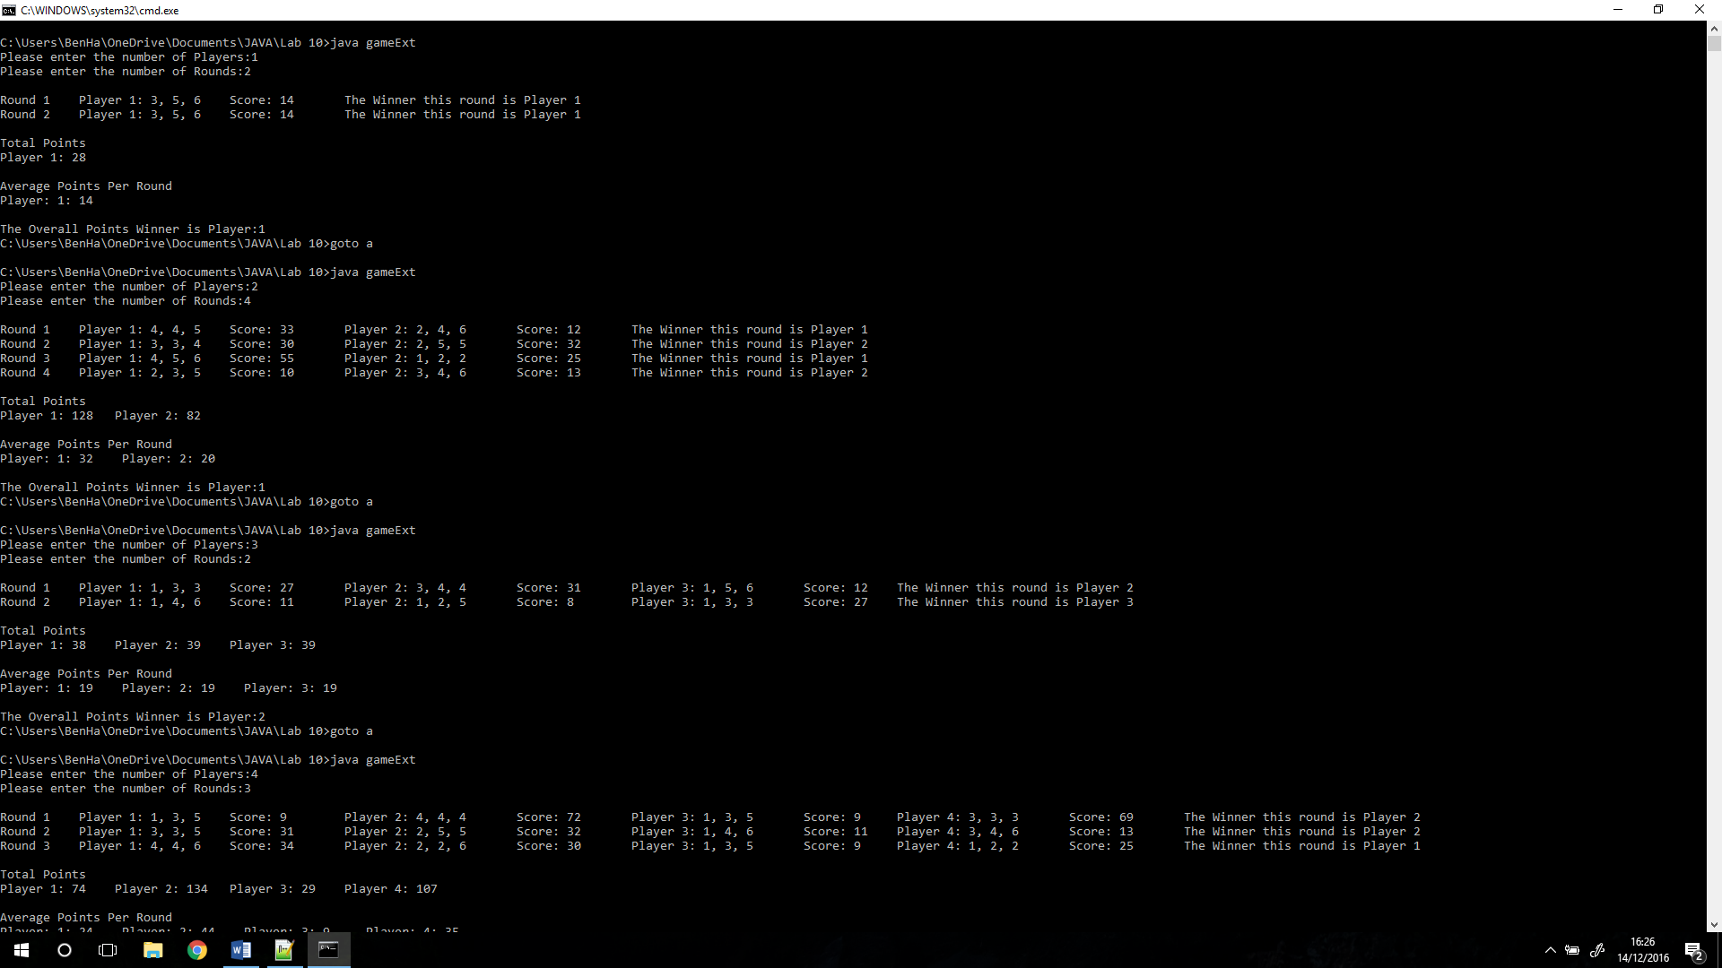

C:\Users\BenHa\OneDrive\Documents\JAVA\Lab 10>java gameExt

Please enter the number of Players:1

Please enter the number of Rounds:2

Round 1 Player 1: 3, 5, 6 Score: 14 The Winner this round is Player 1

Round 2 Player 1: 3, 5, 6 Score: 14 The Winner this round is Player 1

Total Points

Player 1: 28

Average Points Per Round

Player: 1: 14

The Overall Points Winner is Player:1

C:\Users\BenHa\OneDrive\Documents\JAVA\Lab 10>goto a

C:\Users\BenHa\OneDrive\Documents\JAVA\Lab 10>java gameExt

Please enter the number of Players:2

Please enter the number of Rounds:4

Round 1 Player 1: 4, 4, 5 Score: 33 Player 2: 2, 4, 6 Score: 12 The Winner this round is Player 1

Round 2 Player 1: 3, 3, 4 Score: 30 Player 2: 2, 5, 5 Score: 32 The Winner this round is Player 2

Round 3 Player 1: 4, 5, 6 Score: 55 Player 2: 1, 2, 2 Score: 25 The Winner this round is Player 1

Round 4 Player 1: 2, 3, 5 Score: 10 Player 2: 3, 4, 6 Score: 13 The Winner this round is Player 2

Total Points

Player 1: 128 Player 2: 82

Average Points Per Round

Player: 1: 32 Player: 2: 20

The Overall Points Winner is Player:1

C:\Users\BenHa\OneDrive\Documents\JAVA\Lab 10>goto a

C:\Users\BenHa\OneDrive\Documents\JAVA\Lab 10>java gameExt

Please enter the number of Players:3

Please enter the number of Rounds:2

Round 1 Player 1: 1, 3, 3 Score: 27 Player 2: 3, 4, 4 Score: 31 Player 3: 1, 5, 6 Score: 12 The Winner this round is Player 2

Round 2 Player 1: 1, 4, 6 Score: 11 Player 2: 1, 2, 5 Score: 8 Player 3: 1, 3, 3 Score: 27 The Winner this round is Player 3

Total Points

Player 1: 38 Player 2: 39 Player 3: 39

Average Points Per Round

Player: 1: 19 Player: 2: 19 Player: 3: 19

The Overall Points Winner is Player:2

C:\Users\BenHa\OneDrive\Documents\JAVA\Lab 10>goto a

C:\Users\BenHa\OneDrive\Documents\JAVA\Lab 10>java gameExt

Please enter the number of Players:4

Please enter the number of Rounds:3

Round 1 Player 1: 1, 3, 5 Score: 9 Player 2: 4, 4, 4 Score: 72 Player 3: 1, 3, 5 Score: 9 Player 4: 3, 3, 3 Score: 69 The Winner this round is Player 2

Round 2 Player 1: 3, 3, 5 Score: 31 Player 2: 2, 5, 5 Score: 32 Player 3: 1, 4, 6 Score: 11 Player 4: 3, 4, 6 Score: 13 The Winner this round is Player 2

Round 3 Player 1: 4, 4, 6 Score: 34 Player 2: 2, 2, 6 Score: 30 Player 3: 1, 3, 5 Score: 9 Player 4: 1, 2, 2 Score: 25 The Winner this round is Player 1

Total Points

Player 1: 74 Player 2: 134 Player 3: 29 Player 4: 107

Average Points Per Round

Player: 1: 24 Player: 2: 44 Player: 3: 9 Player: 4: 35

The Overall Points Winner is Player:2

C:\Users\BenHa\OneDrive\Documents\JAVA\Lab 10>goto a

C:\Users\BenHa\OneDrive\Documents\JAVA\Lab 10>java gameExt

Please enter the number of Players:5

Please enter the number of Rounds:5

Round 1 Player 1: 1, 5, 5 Score: 31 Player 2: 1, 2, 6 Score: 9 Player 3: 1, 2, 4 Score: 7 Player 4: 1, 4, 6 Score: 11 Player 5: 2, 2, 5 Score: 29 The Winner this round is Player 1

Round 2 Player 1: 3, 3, 5 Score: 31 Player 2: 1, 5, 6 Score: 12 Player 3: 2, 6, 6 Score: 34 Player 4: 1, 3, 6 Score: 10 Player 5: 2, 4, 4 Score: 30 The Winner this round is Player 3

Round 3 Player 1: 1, 4, 6 Score: 11 Player 2: 5, 6, 6 Score: 37 Player 3: 2, 4, 5 Score: 11 Player 4: 1, 5, 5 Score: 31 Player 5: 2, 2, 6 Score: 30 The Winner this round is Player 2

Round 4 Player 1: 2, 2, 3 Score: 27 Player 2: 1, 2, 2 Score: 25 Player 3: 3, 3, 6 Score: 32 Player 4: 2, 4, 5 Score: 11 Player 5: 2, 3, 4 Score: 49 The Winner this round is Player 5

Round 5 Player 1: 3, 3, 5 Score: 31 Player 2: 1, 5, 5 Score: 31 Player 3: 2, 2, 2 Score: 66 Player 4: 1, 6, 6 Score: 33 Player 5: 5, 6, 6 Score: 37 The Winner this round is Player 3

Total Points

Player 1: 131 Player 2: 114 Player 3: 150 Player 4: 96 Player 5: 175

Average Points Per Round

Player: 1: 26 Player: 2: 22 Player: 3: 30 Player: 4: 19 Player: 5: 35

The Overall Points Winner is Player:5

C:\Users\BenHa\OneDrive\Documents\JAVA\Lab 10>goto a

C:\Users\BenHa\OneDrive\Documents\JAVA\Lab 10>java gameExt

Please enter the number of Players:6

Please enter the number of Rounds:6

Round 1 Player 1: 2, 6, 6 Score: 34 Player 2: 4, 6, 6 Score: 36 Player 3: 1, 4, 6 Score: 11 Player 4: 2, 5, 6 Score: 13 Player 5: 1, 3, 5 Score: 9 Player 6: 2, 4, 5 Score: 11 The Winner this round is Player 2

Round 2 Player 1: 2, 3, 4 Score: 49 Player 2: 1, 3, 4 Score: 8 Player 3: 2, 4, 4 Score: 30 Player 4: 1, 4, 4 Score: 29 Player 5: 3, 4, 5 Score: 52 Player 6: 3, 6, 6 Score: 35 The Winner this round is Player 5

Round 3 Player 1: 1, 3, 6 Score: 10 Player 2: 2, 4, 6 Score: 12 Player 3: 2, 4, 5 Score: 11 Player 4: 4, 5, 6 Score: 55 Player 5: 1, 3, 5 Score: 9 Player 6: 2, 2, 5 Score: 29 The Winner this round is Player 4

Round 4 Player 1: 3, 3, 5 Score: 31 Player 2: 3, 4, 6 Score: 13 Player 3: 4, 6, 6 Score: 36 Player 4: 1, 5, 6 Score: 12 Player 5: 2, 3, 6 Score: 11 Player 6: 1, 5, 6 Score: 12 The Winner this round is Player 3

Round 5 Player 1: 2, 4, 6 Score: 12 Player 2: 1, 4, 5 Score: 10 Player 3: 2, 2, 4 Score: 28 Player 4: 1, 2, 5 Score: 8 Player 5: 3, 3, 6 Score: 32 Player 6: 1, 4, 4 Score: 29 The Winner this round is Player 5

Round 6 Player 1: 2, 5, 5 Score: 32 Player 2: 1, 3, 4 Score: 8 Player 3: 3, 4, 6 Score: 13 Player 4: 1, 6, 6 Score: 33 Player 5: 1, 2, 3 Score: 46 Player 6: 1, 4, 5 Score: 10 The Winner this round is Player 5

Total Points

Player 1: 168 Player 2: 87 Player 3: 129 Player 4: 150 Player 5: 159 Player 6: 126

Average Points Per Round

Player: 1: 28 Player: 2: 14 Player: 3: 21 Player: 4: 25 Player: 5: 26 Player: 6: 21

The Overall Points Winner is Player:1

C:\Users\BenHa\OneDrive\Documents\JAVA\Lab 10>goto a

C:\Users\BenHa\OneDrive\Documents\JAVA\Lab 10>java gameExt

Please enter the number of Players:7

Please enter the number of Rounds:2

Round 1 Player 1: 2, 6, 6 Score: 34 Player 2: 4, 4, 6 Score: 34 Player 3: 1, 4, 6 Score: 11 Player 4: 1, 1, 3 Score: 25 Player 5: 2, 2, 6 Score: 30 Player 6: 1, 4, 6 Score: 11 Player 7: 3, 3, 5 Score: 31 The Winner this round is Player 1

Round 2 Player 1: 1, 3, 5 Score: 9 Player 2: 2, 4, 4 Score: 30 Player 3: 3, 4, 6 Score: 13 Player 4: 2, 5, 6 Score: 13 Player 5: 2, 2, 3 Score: 27 Player 6: 2, 5, 6 Score: 13 Player 7: 1, 2, 5 Score: 8 The Winner this round is Player 2

Total Points

Player 1: 43 Player 2: 64 Player 3: 24 Player 4: 38 Player 5: 57 Player 6: 24 Player 7: 39

Average Points Per Round

Player: 1: 21 Player: 2: 32 Player: 3: 12 Player: 4: 19 Player: 5: 28 Player: 6: 12 Player: 7: 19